# Interdisciplinary Senior Capstone Project

**Ai Assisted Farming Drone**

A Design Project Final Report submitted to the Department(s) of Electrical Engineering, Mechanical Engineering, Computer Science, College of Engineering and Applied Science at the University of Cincinnati in partial fulfillment of the requirements for the degree of Bachelor of Science

Team Members:

Cade Smeller - Electrical Engineering, Team lead

Leia Dalcomune - Electrical Engineering

He Yingrui - Electrical Engineering

Xu Siyi - Electrical Engineering

Kuilin Shen - Mechanical Engineering

Matthew Shamray - Computer Science

Advisor:

Mohsen Rezayat, Mechanical and Materials Engineering External Advisory Board

Instructor:

Wei Wei, Electrical & Computer Engineering

Fred Annexstein, Computer Science

Industry Project Sponsor

Omid USA

4/29/2025

**Executive Summary / Abstract**

The Ai Assisted Farming Drone project aims to provide smallholder farmers with affordable and adaptable monitoring technology to enhance agricultural productivity, using the monitoring of grape crops in Ohio's vineyards as a case study. In partnership with OMID USA, the project addresses the limitations of traditional agricultural drones by providing a scalable solution tailored for smallholder farmers. Utilizing the MicaSense RedEdge-MX™ multispectral camera and Raspberry Pi 5 (8GB), the system integrates multispectral imaging and AI analytics to detect diseases such as downy mildew, powdery mildew, black rot, and lantern flies.

The drone focuses on a X650 Holybro Drone kit while ensuring compatibility with other farming equipment, like tractors, to maximize flexibility for farmers. The project also involved collaboration with the Control Box team to integrate stationary sensors for a comprehensive monitoring solution. The solution focuses on being simple, affordable, and flexible, supporting OMID USA’s mission to help underserved farming communities.

**Project Description**

**Problem Statement**

Smallholder farmers across the world face challenges in identifying and managing plant diseases and pests due to the high costs and proprietary nature of existing agricultural drones. This makes it difficult for them to maintain crop health and maximize yields effectively.

**Introduction & Background**

OMID USA is a non-profit organization dedicated to empowering smallholder farmers through sustainable and affordable solutions. Starting in Ohio we will create a solution that can be tested here and then replicated in a more high impact area. In Ohio diseases such as downy mildew, powdery mildew, and black rot, along with pests like lantern flies, pose severe threats to vineyard productivity.

Current agricultural technologies are either too expensive or incompatible with small-scale operations. This project seeks to bridge this gap by developing a flexible, low-cost drone-based monitoring system tailored to Ohio’s grape crops.

**Objectives:**

* Implement a portable multispectral camera system that can be mounted on various agricultural equipment.
* Develop a fine tunable AI-driven system for grape crop health monitoring.
* Achieve "AI-assisted crop monitoring using stationary and mobile sensors" in collaboration with the Control Box team.

**Success Criteria:**

* Develop a mounting harness for the multispectral camera on various agricultural equipment, including drones and tractors.
* Accurate detection of grape-specific diseases (>75%).
* Cost-effective implementation accessible to smallholder farmers.
* User-friendly interface and compatibility with diverse equipment.

**Considerations for Stakeholders:**

* OMID USA’s $6,000 budget requires allocation between research costs and ensuring affordability for farmers.
* The system must integrate with a drone and control box, and be adaptable to other agricultural tools.
* The software interface must prioritize simplicity and portability, enabling farmers with limited technical expertise to easily operate the system.
* By focusing on Ohio’s grape crops, the project demonstrates a scalable model that can be applied to other regions and crop types.

**Design Constraints Identification [ABET 2, (4)]**

**1. Constraints Specified by Customers and/or Stakeholders**

**Reason:**

* Omid USA is our sponsor company and their mission is to make high subsistence farmers' lives easier and more productive.
* The core target audience for the project is farmers, whose needs are clear: they expect the equipment to be simple, easy to use, fully functional, and accurate enough to significantly reduce pest and disease impact on crop yield.

**Constraints:**

* The user interface design must support intuitive operation to reduce the learning curve for farmers using new technology.
* The AI model must be adaptable to various crops and pest diseases, with regular database updates to improve prediction accuracy.
* The spectral camera must be optimized to suit various agricultural environments, including different crop planting densities and regional climate variations.
* Harness/Assembly must be compatible with typical drone mounting and common farm equipment.
* Whole project must be made as affordable as possible to try to encourage replication around the world.

**2. Ethical and Professional Responsibility (ABET 4)**

**Reason:**

* Drones are used for field data collection, which may raise privacy concerns; it is essential to ensure data security and lawful use.
* The AI model's design must avoid potential biases in training data, such as neglecting health issues for certain crops or inaccurate predictions for specific geographic regions.

**Constraints:**

* Data collection must be transparent, ensuring that users are informed and obtain consent, in compliance with U.S. privacy laws (such as CCPA).
* Use diversified training data, covering various pest diseases and environmental variables from different regions.
* All technical documentation must meet professional standards, providing open support for third-party review and improvement.

**3. Health and Safety Constraints (ABET 2)**

**Reason:**

* The drone's flight design may affect user operational safety, and the drone's noise could cause disturbances.

**Constraints:**

* The flight system must ensure safe operation in densely planted farmlands.
* Equipment operation must comply with FAA drone flight safety regulations, such as pilot certification and operation range limitations.

**4. Cultural Diversity and Accessibility (ABET 2)**

**Reason:**

* The target users include farmers with varying technical expertise, covering both the U.S. domestic market and potential international markets. The device must be easy to use and support accessible options across different cultural contexts.

**Constraints:**

* The interface design must support multiple languages, including English and Spanish, and symbols should be clear and simple.
* Provide detailed user manuals or online video tutorials to help users with limited technical knowledge quickly get up to speed.

**5. Economic Constraints (ABET 2)**

**Reason:**

* With a budget of only $6,000, the goal is to maximize functionality within limited resources. The product must be economically viable for the target market and affordable for the average farmer.

**Constraints:**

* Choose high-cost performance spectral camera modules, such as mid-range resolution devices, and use open-source technologies to reduce software development costs.
* Optimize component integration and manufacturing processes to reduce material and production costs while ensuring reliable performance.

**6. Environmental Constraints (ABET 2)**

**Reason:**

* Drones will be used long-term in agricultural environments, so it is important to minimize ecological impact. Additionally, the use of spectral cameras may have unintended effects on the environment or crops.

**Constraints:**

* The design must use low-noise motors to avoid disturbing the natural environment or farmland fauna (e.g., insects and birds).
* All equipment must meet environmental and sustainability standards to avoid any negative impact on the farmland ecosystem.

**7. Sustainability Considerations (ABET 2)**

**Reason:**

* The sustainability of the drone system is crucial for long-term use, especially in agriculture. Farmers need a long-term, reliable solution, rather than frequently replacing equipment or dealing with high maintenance costs.

**Constraints:**

* The design must ensure long service life, supporting component replacements to reduce the overall equipment waste rate.
* The software system should support online updates and be compatible with future algorithm expansions and technological improvements.

**8. Legal and Regulatory Constraints**

**Reason:**

* Compliance with U.S. FAA drone flight regulations and data protection laws, such as GDPR (for international market expansion), is a basic requirement for the project.

**Constraints:**

* Ensure that the drone complies with FAA regulations regarding flight altitude, range, and geofencing requirements.
* The design for data storage and processing must comply with U.S. CCPA and international GDPR privacy protection standards.

**9. Security Considerations**

**Reason:**

* It is important to ensure that the equipment and data are protected from malicious attacks during real-world application.

**Constraints:**

* Develop secure communication protocols to prevent drone data from being intercepted by hackers.
* Encrypt data storage to protect sensitive farmer information from unauthorized access.

**10. Manufacturing Feasibility**

**Reason:**

* Manufacturing costs and supply chains will directly affect the product’s development timeline and affordability.

**Constraints:**

* Prioritize existing spectral camera and drone components available in the market to reduce R&D time and manufacturing complexity.
* Implement modular design with widely available parts to facilitate maintenance and cost control.

## **Engineering Standards and Codes Applied to the Project [ABET 2] [ETAC] Program Crit,/ ETAC**

Engineering projects in the real world often rely on established standards and codes to ensure compliance with relevant regulations, environmental, and technical constraints. For our project, we have adopted three key standards to guide the development and implementation: FAA Part 107, ISO 14001, and IEEE 802.11. These standards address specific challenges related to operational safety, environmental sustainability, and communication reliability. The following sections detail the research process for identifying these standards and their application to the project.

**1.FAA Part 107: Small Unmanned Aircraft Systems (sUAS) Regulations**

**Research Process:**

FAA Part 107, established by the Federal Aviation Administration (FAA), is a regulatory framework aimed at governing the operation of small unmanned aircraft systems (sUAS) in the United States. The research process included a thorough review of the FAA's official website and related academic and industry literature to gain a comprehensive understanding of operational restrictions and requirements. Key regulations include:

* Maximum flight altitude of 400 feet above ground level.
* Remote pilots must obtain Part 107 certification.
* Unauthorized operations in controlled airspace are prohibited.

**Application to the Project:**

To ensure compliance with FAA Part 107:

1. **Flight Altitude Restrictions:** The drone design integrates geofencing functionality to limit flight altitude to 400 feet. This is achieved through a combination of GPS and software algorithms.
2. **Pilot Certification:** The project mandates that all operators must hold a valid FAA Part 107 certification. Training materials and simulated tests are provided to help operators easily pass the certification process.
3. **Airspace Monitoring:** The system incorporates the FAA’s B4UFLY mobile app, which uses GPS to provide real-time airspace restrictions and flight requirements. Additionally, the project adheres to FAA standards, including maintaining a flight altitude below 400 feet, operating only within visual line-of-sight, avoiding restricted airspace, complying with airspace restrictions, and ensuring the drone operates within FAA-approved Flight Restrictions (FRIAs) to ensure operational safety and compliance.

**2. ISO 14001: Environmental Management Systems**

**Research Process:**

ISO 14001 is an international standard focused on reducing environmental impact through effective environmental management systems. The research involved studying key principles in the ISO documents related to lifecycle analysis, waste management, and noise pollution mitigation.

**Application to the Project:**

The project aims to minimize its environmental footprint through the following measures:

1. **Low-Noise Design:** The system will prioritize low-noise motors to reduce environmental disturbance, thereby minimizing noise pollution.
2. **Sustainable Materials:** The manufacturing process will prioritize recyclable and biodegradable materials to reduce long-term waste.
3. **Energy Efficiency:** The flight route planning and data processing algorithms are optimized to reduce energy consumption, thereby extending battery life and reducing the frequency of recharges.

**3. IEEE 802.11: Wireless Communication Standard**

**Research Process:**

IEEE 802.11 (commonly known as Wi-Fi) is a widely used standard for wireless communication. The research process included reviewing technical specifications to assess its suitability for data transmission between drones, onboard sensors, and ground control stations. Key considerations include bandwidth, latency, and encryption protocols.

**Application to the Project:**

1. **Low-Noise Design:** The system will prioritize low-noise motors to reduce environmental disturbance, thereby minimizing noise pollution.
2. **Data Security:** Advanced encryption protocols from IEEE 802.11 are employed to ensure data integrity and prevent unauthorized access.

**4. Maximize Affordability**

**Research Process:**

Plenty of research went into each of our potential components, making sure that all meet the required specs. Our final decision making process prioritized the cost of the components second after its ability to do the job.

**Application to the Project:**

1. **Cost:** Low cost is instrumental to our goal of helping low income and high subsistence farmers around the world.
2. **Quality:** Cost however should not come at the impact of longevity or the ability for our project to perform its job to our standards.

## **Design Considerations**

* **Accessibility**

As this product is aimed to be reproduced by people with lower income, it is essential that the cost of the full product is as low as possible for accessibility.

* **Ease of use**

The users of this product might not have experience with such technology, making ease of use a large design consideration on both the UI and hardware fronts.

* **Trainable AI model**

Ideally users can train their AI to recognize the types of pests that are endemic to the area to best utilize the full potential of the product.

* **Geographic Accuracy** 
  + To achieve our goals of helping to reduce runoff from agricultural spraying it is key that our drone can accurately pinpoint where it encountered a potential pest or disease.

## **Design Process, Alternatives, and Basis for Selection**

## 

* Identification of Multiple Design Alternatives [ABET 2]
  + NVIDIA Jetson Xavier NX and Raspberry PI for the computer, TensorFlow, PyTorch, for model training, image cv for the image processing, and Parrot SEQUOIA, Micasense RedEdge-P, and Micasense RedEdge-MX for cameras.
  + Decision processes to determine the design alternatives were done on the basis of how well it aligned with our design considerations as well as if it met or exceeded our spec requirements.
  + The list of alternates is as follows
    - NVIDIA Jetson Xavier NX is a compact and powerful AI computing platform designed for edge devices, offering high performance and energy efficiency. It is part of NVIDIA's Jetson family, which is tailored for machine learning, computer vision, robotics, and other AI applications in embedded systems.
    - The Raspberry Pi 5 is a powerful and versatile single-board computer that builds upon its predecessors with several improvements, including higher performance and expanded connectivity.
    - TensorFlow is an open-source machine learning library developed by Google for creating and deploying machine learning models. It supports deep learning, neural networks, and other advanced algorithms, and is widely used for both research and production purposes.
    - PyTorch is another leading open-source machine learning library, primarily developed by Facebook's AI Research lab. Like TensorFlow, it is widely used for deep learning and neural network-based applications.
    - OpenCV (Open Source Computer Vision Library) is an open-source computer vision and machine learning software library. It provides over 2,500 optimized algorithms for real-time image processing, computer vision, and video analysis tasks. OpenCV supports a variety of operations, such as object detection, face recognition, and motion tracking. It is designed to be highly efficient, with support for both CPU and GPU-based processing.
    - Convolutional Neural Networks (CNNs): A class of deep learning models particularly well-suited for spatial data like images.
    - Semantic Segmentation Models: These models assign a class label to each pixel in an image, enabling precise region-level classification. Common architectures in this category include UNet and DeepLab.
    - Transformer-Based Models: Emerging models that apply self-attention mechanisms to capture global relationships in visual data.
    - The Parrot SEQUOIA is a very well specced camera capturing all the bands that we require for pest detection.
    - Micasense RedEdge-P is an incredibly capable camera, capturing all the bands we require but being able to do so from a higher distance than most other cameras.
    - Micasense RedEdge-MX is a very capable camera, capturing all needed bands we require and costing the least that we could find.
* Determination of basis for design alternative selection [ABET 2].
  + Raspberry Pi 5 was selected on the basis of its low cost and ability to do what we need it to. The NVIDIA model was pricey and overpowered for our needs, while the Raspberry Pi matches our cost constraint well.
  + OpenCV was selected because of its optimized pre existing algorithms for image processing, we plan to utilize these algorithms for our application.
  + PyTorch was selected for model development due to its flexibility, community support, and ease of implementing custom input pipelines.
  + The MicaSense RedEdge-MX is our choice as it can capture all the data we are looking for and we were able to find a vendor selling it for about a third of the price of the other cameras available. This camera best keeps in mind our cost goals while delivering the performance needed.
  + ResNet-18 (CNN) was selected due to its balance of representational power and small footprint. Its modular architecture allowed modification for 7-channel inputs, and best fit the requirments for the visualization and constraints from the datasets.

## **Design Overview [ABET 1]**

## **Basic Diagram for Camera Assembly:**

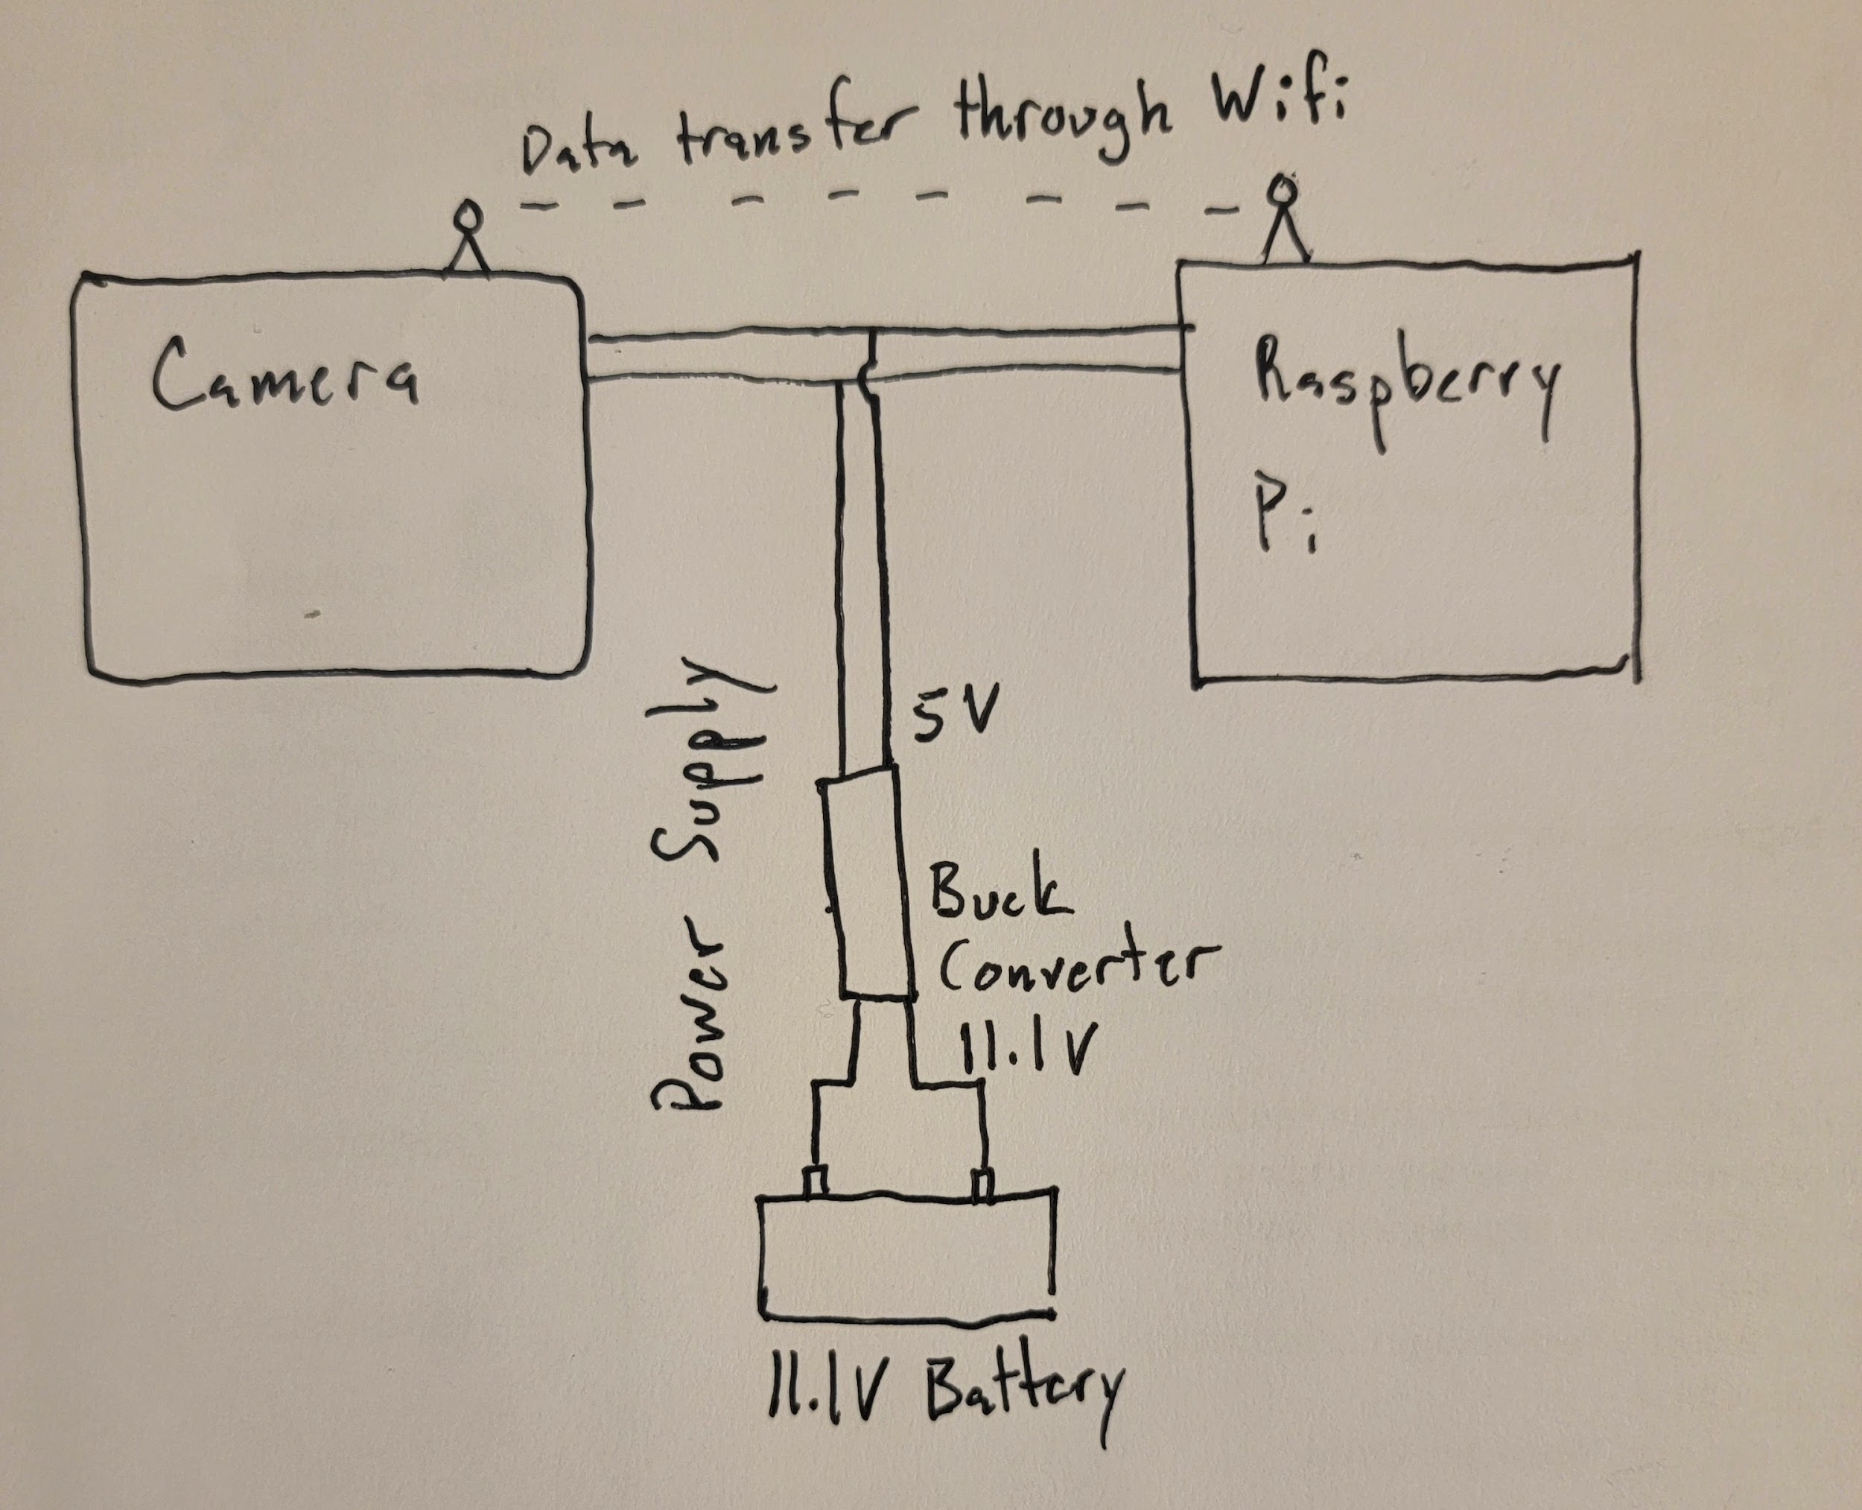

We utilized a 11.1V Lithium Ion Battery and a Step Down Buck Converter to get our desired 5V power supply to the electronics inside our camera assembly. The data transfer was handled through a Wifi connection allowing for only one cable in the tight enclosure.

**Enclosure with Components:**

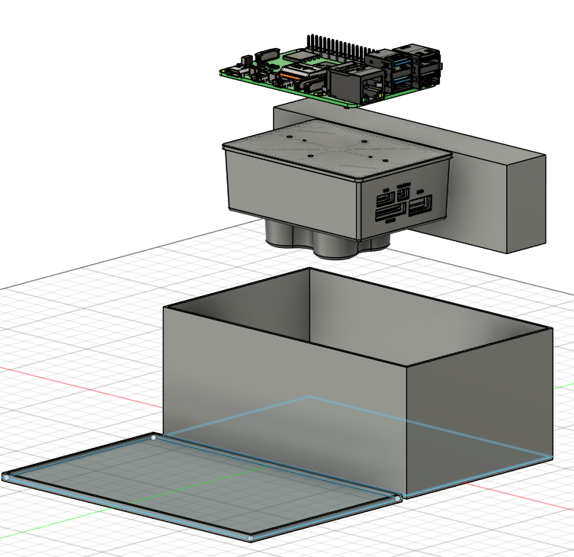

**Enclosure with Foam Insulation to Reduce Vibration**

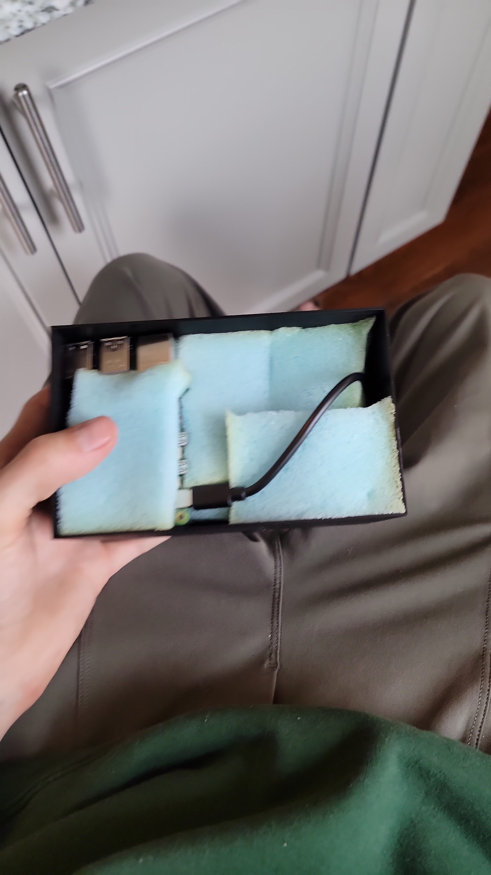

**Enclosure After Assembly Attached to the Drone:**

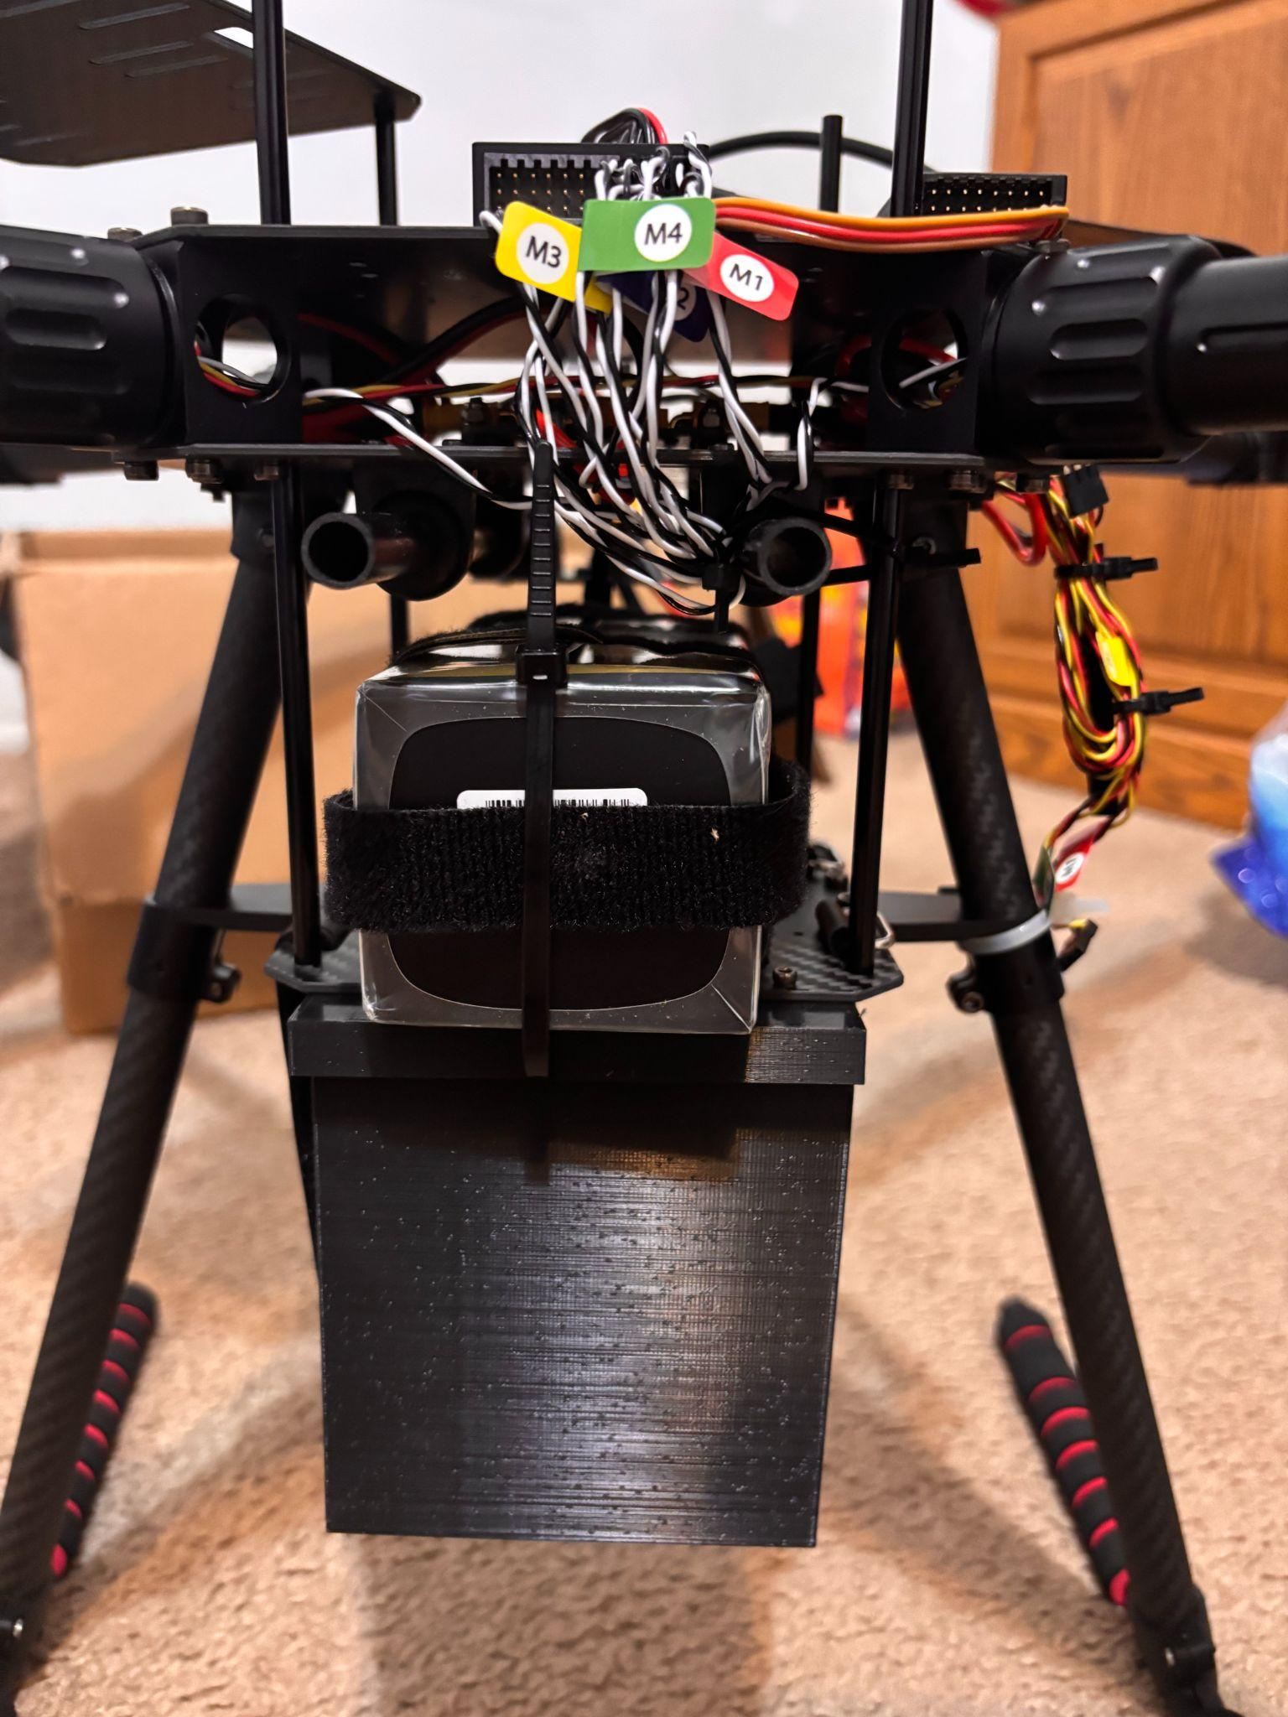

We decided to attach the enclosure lid to the baseplate of the drone then using some velcro strap that came with the X650 kit, we securely attach the bottom of the enclosure to the lid, securing it in all axes.

**Drone Assembly:**

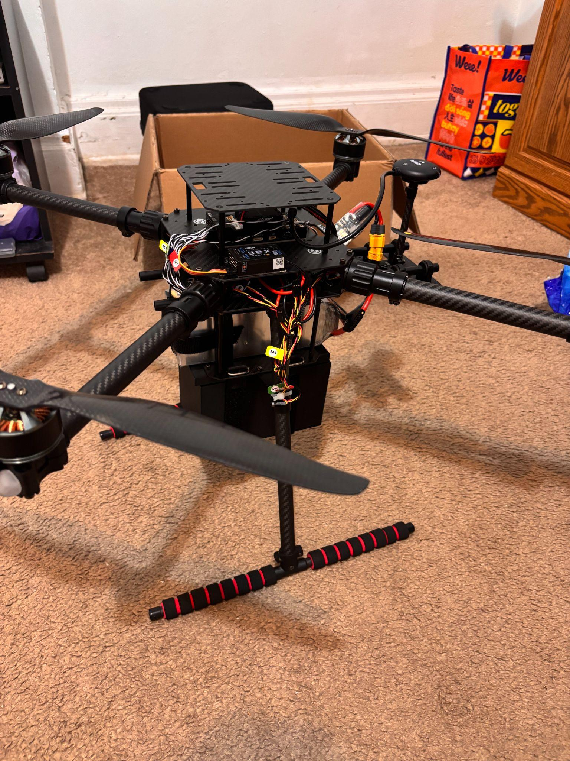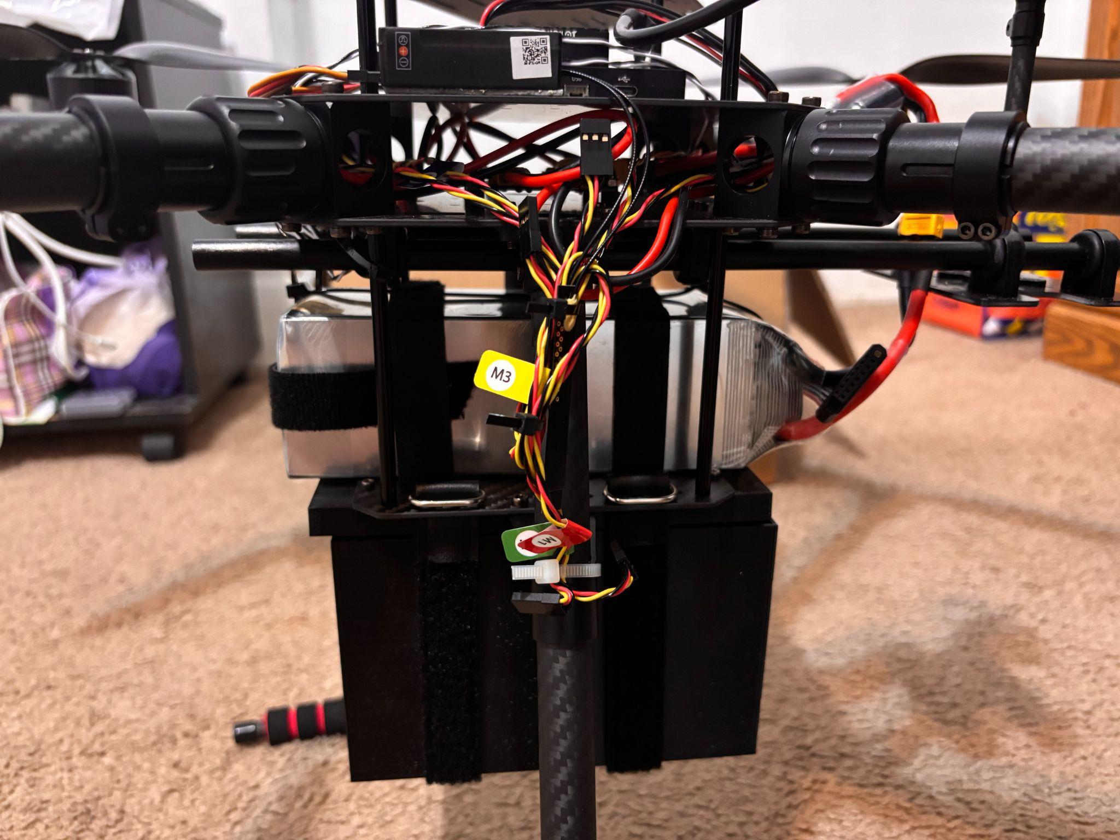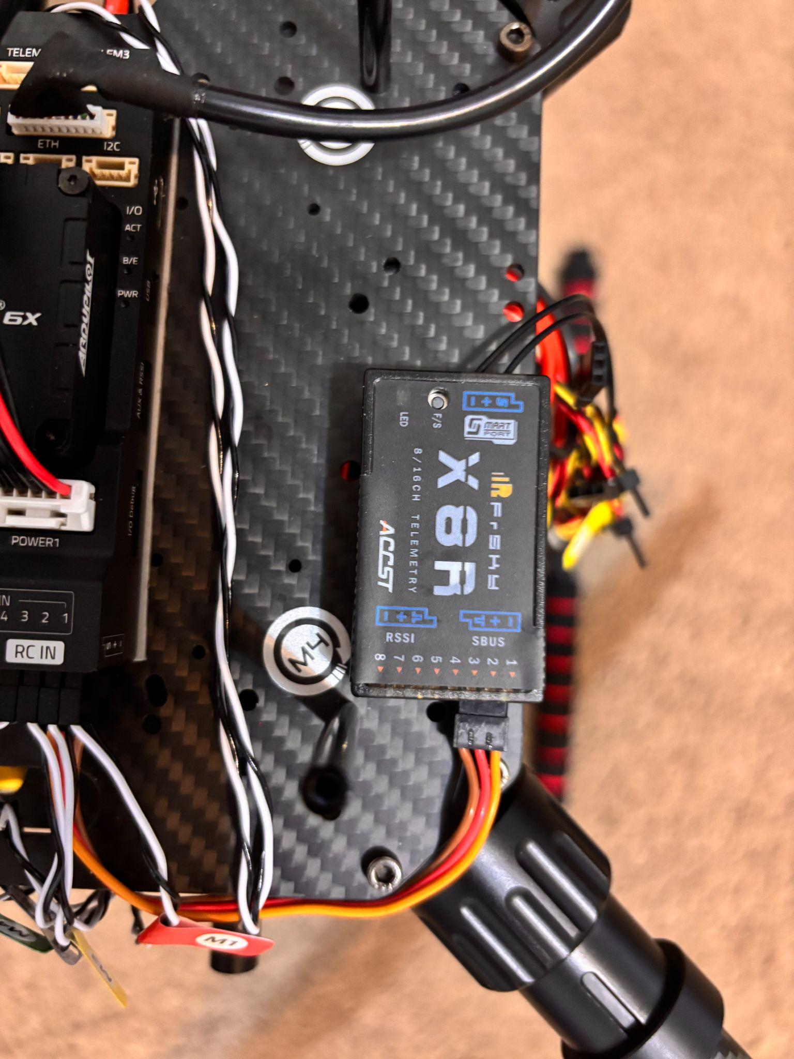

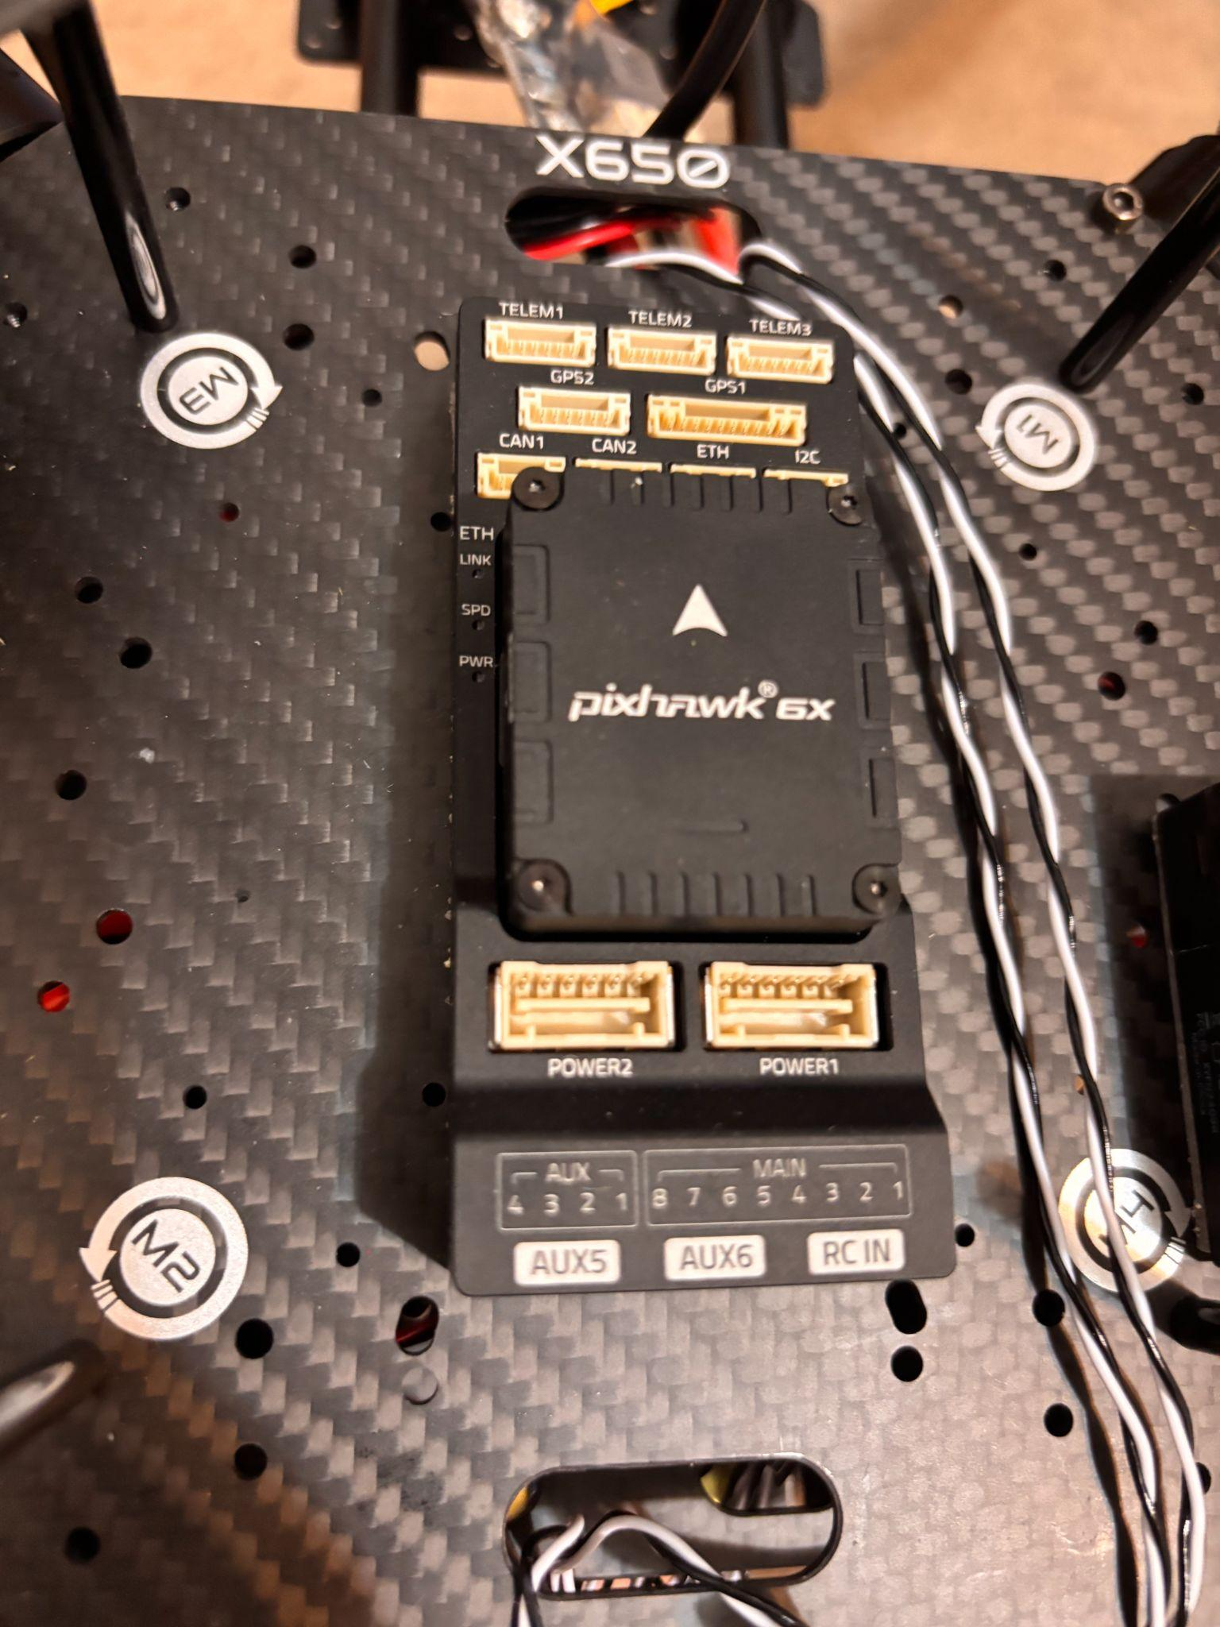

The drone was built per Holybros instructions. The Pixhawk 6X flight controller was set up per the company's instructions as well.

**Drone Ground Station:**

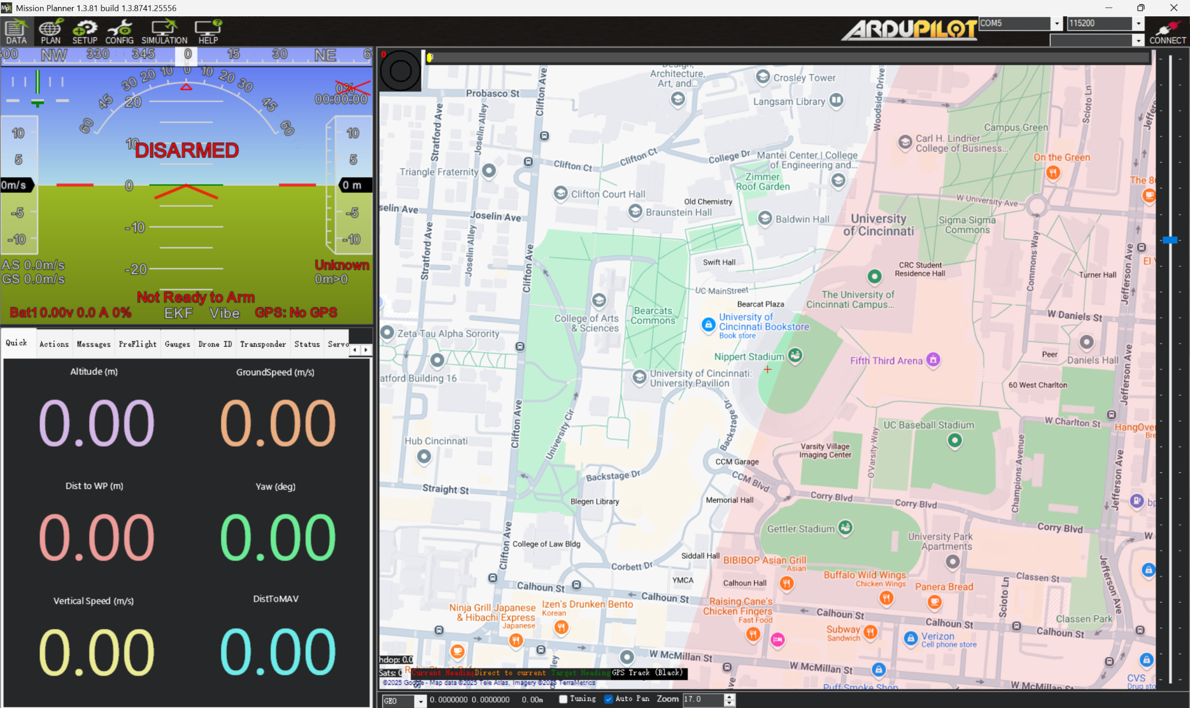

Pixhawk 6X was connected to the Ground Station software ArduPilot to have a computer display of the drone's condition as well as to set up the remote control we purchased for the drone as well.

**Drone Controller:**

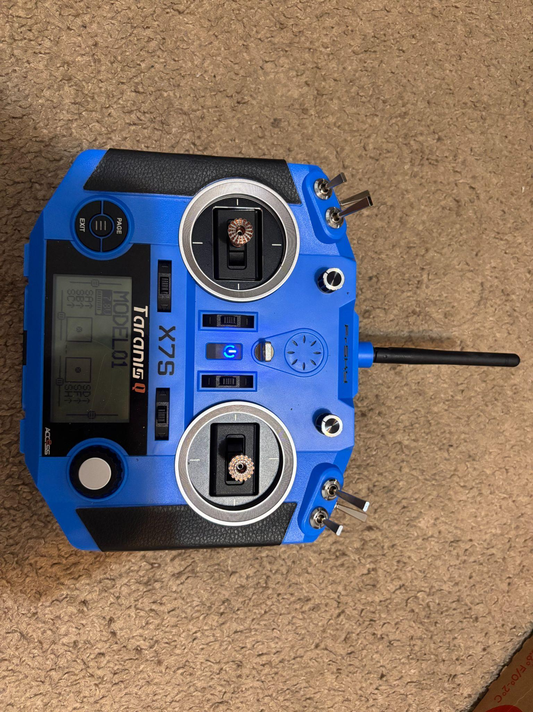

## BOM:

| Camera | RedEdge-MX micasense | $3099.00 |
| --- | --- | --- |
| Drone and flight control | Holybro X650 development kit;  Pixhawk 6X | $897.30 |
| Drone Battery | Tattu G-Tech 6S 11000mAh | $216.99 |
| Battery Charger | Tattu TA1000 G-Tech Dual-channel Charger | $259.99 |
| Drone Receiver | FrSky X8R 16ch Receiver | $55.49 |
| Drone Remote | FrSky Taranis Q X7S Radio Transmitter | $281.99 |
| Camera Battery | OVONIC Lipo Battery 5200mAh 50C 11.1V | $25.64 |
| Camera Battery Charger | LiPo Battery Charger 2S-3S RC Balance Charger | $15.99 |
| Computer | Raspberry Pi 5 8GB | $80 |
| Cabling | USB-C, DF-13, and Deans-T Connectors | ~$34 |
| Enclosure | Cade | Free |
| Licensing | FAA Drone Licensure | $175 |
| Services | Google Cloud Platform | ~$50 |

**System Architecture**

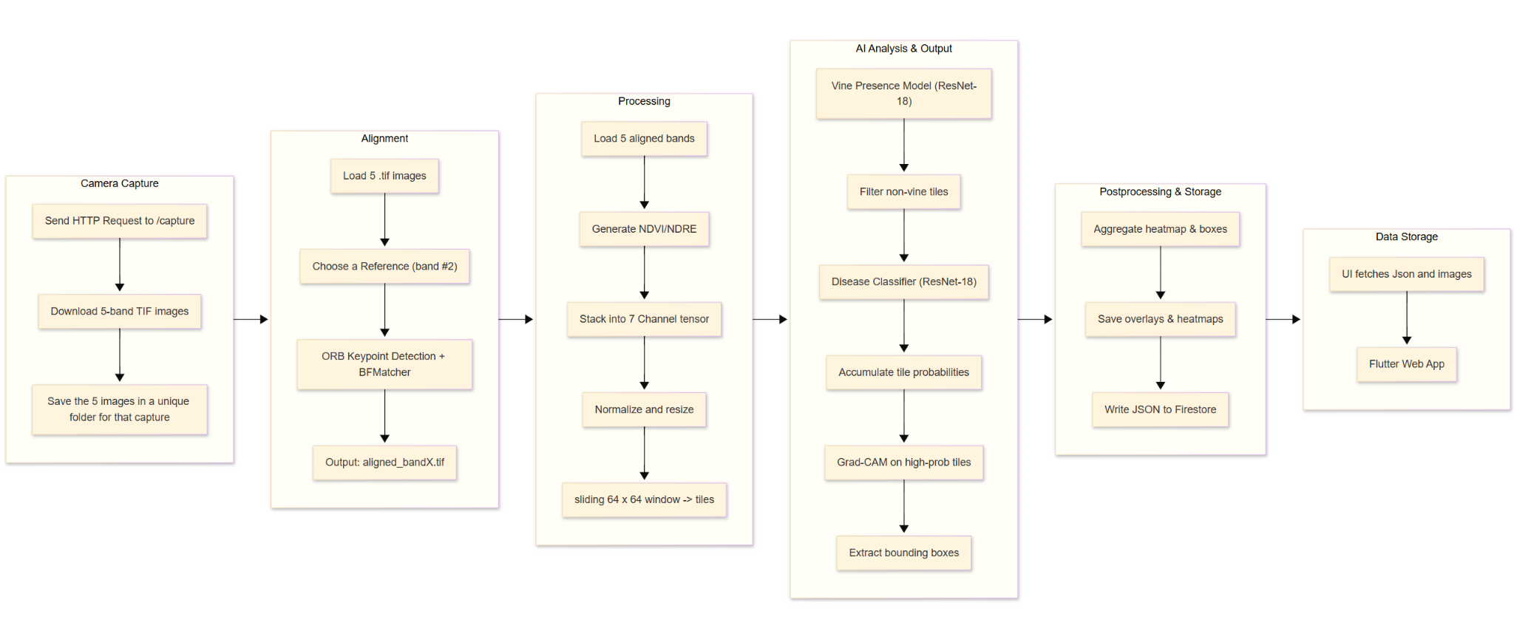

**Dataset**

The dataset consists of aerial multispectral images collected from drone flights over vineyard plots. Each image includes five spectral bands (Blue, Green, Red, NIR, and RedEdge). Training labels were generated using georeferenced shapefiles marking vine rows and known diseased vine clusters. Tiles with at least 20% overlap with vine polygons were labeled as vine-positive, while tiles intersecting known disease polygons were labeled diseased.

The final dataset included approximately 3,000 tiles for vine presence classification and 824 disease-positive samples for the disease classification model.

**Data Acquisition and Preprocessing**

The multispectral camera captures five individual bands: Blue, Green, Red, Near-Infrared(NIR), and Redege. These images are retrieved through the camera's HTTP API, initiated by scripts running on a Raspberry Pi. Each capture event is stored locally within a uniquely time stamped folder named capture_{timestamp}. To enhance insight, two vegetation indices are computed: NDVI and NDRE. These are calculated using standard spectral formulas and then stacked with the original 5 bands to create a 7-channel input tensor.

$NDVI=\frac{NIR-Red}{NIR+Red}​, NDRE=\frac{NIR -RedEdge}{NIR+RedEdge}​$

Each image is then divided into overlapping 64x64 pixel tiles using a sliding window approach (stride = 32). Every tile is normalized using global mean and standard deviation values computed from the training set (global_mean.npy, global_std.npy).

**Model Architecture and training**

a two-stage classification pipeline was selected for inference. First, a vine presence classifier based on a modified ResNet-18 architecture determines whether a tile contains vineyard rows. Only tiles that are positively identified as containing vines proceed to the second model. The second model is a disease classifier, which is also a 7-channel ResNet-18. This model assesses the likelihood of disease symptoms within each vine tile.

Both models were trained using cross-entropy loss and the Adam optimizer. Data augmentations, such as random flips and rotations were applied. A patience based early stopping mechanism was also used to prevent the models from overfitting.

**Inference**

At inference time, each image is processed through both classifiers in sequence. Tile level disease probabilities are gathered to form a continuous heatmap. Grad-CAM (Gradient-weighted Class Activation Mapping) is applied to high-confidence disease tiles, which generates spatial attention maps, highlighting the regions of each tile most influential in the classification decision.

Bounding boxes are extracted from the Grad-CAM activations. The model can provide localized predictions without requiring pixel-level segmentation labels.

**Output, Storage, and Visualization**

An RGB composite image with bounding boxes, NDVI/NDRE images, heatmap, and the original 5 bands are stored in Firebase Storage. prediction metadata are written to the Firestore as JSON documents.

**Script Responsibilities**

| Script | Core function |
| --- | --- |
| Camera_data.py | Captures multispectral images via HTTP API and saves to timestamped directories |
| align_images.py | ORB alignment to red band |
| process_images_new.py | Generate NDVI/NDRE + RGB Composite |
| run_inference.py | Performs two-stage inference (vine detection, disease classification, Grad-CAM extraction) |
| firebase_upload.py | Handles upload of inference results and metadata to Firebase Storage and Firestore |
| start_pipeline.py | Coordinates the end-to-end processing pipeline from image capture through inference |
| server.py | Hosts a Flask server to manage incoming requests and serve prediction results |

**Orchestration (start_pipeline.py)**

Two daemon threads – capture_worker and processing_worker – share a queue so the camera keeps shooting while other threads crunch previous captures.

**Remote Control API (server.py)**

GET /ping – online status check

POST /start-capture?mode=single|continuous – spawns *start_pipeline.py*

**Flutter Web App Interface**

The Vinovoltaics web interface is built in Flutter and integrates with Firebase Auth, Firestore, and Storage. It provides a responsive layout tailored to both desktop and mobile displays, featuring a clean Material 3 design with custom theming.

On desktop and wide-screen displays, the app utilizes a NavigationRail on the left side for switching between sections such as Stationary Sensors, Mobile Sensors, and Settings. Each section is rendered on the right-hand pane, creating a clear and efficient two-column layout. On mobile or narrow screens, the app transitions to a bottom navigation bar with equivalent functionality.

Upon launch, users are met with a login screen where authentication is handled via Google Sign-In. The logic adjusts based on platform, offering a web-specific flow for Firebase Auth or defaulting to a direct page transition on mobile.

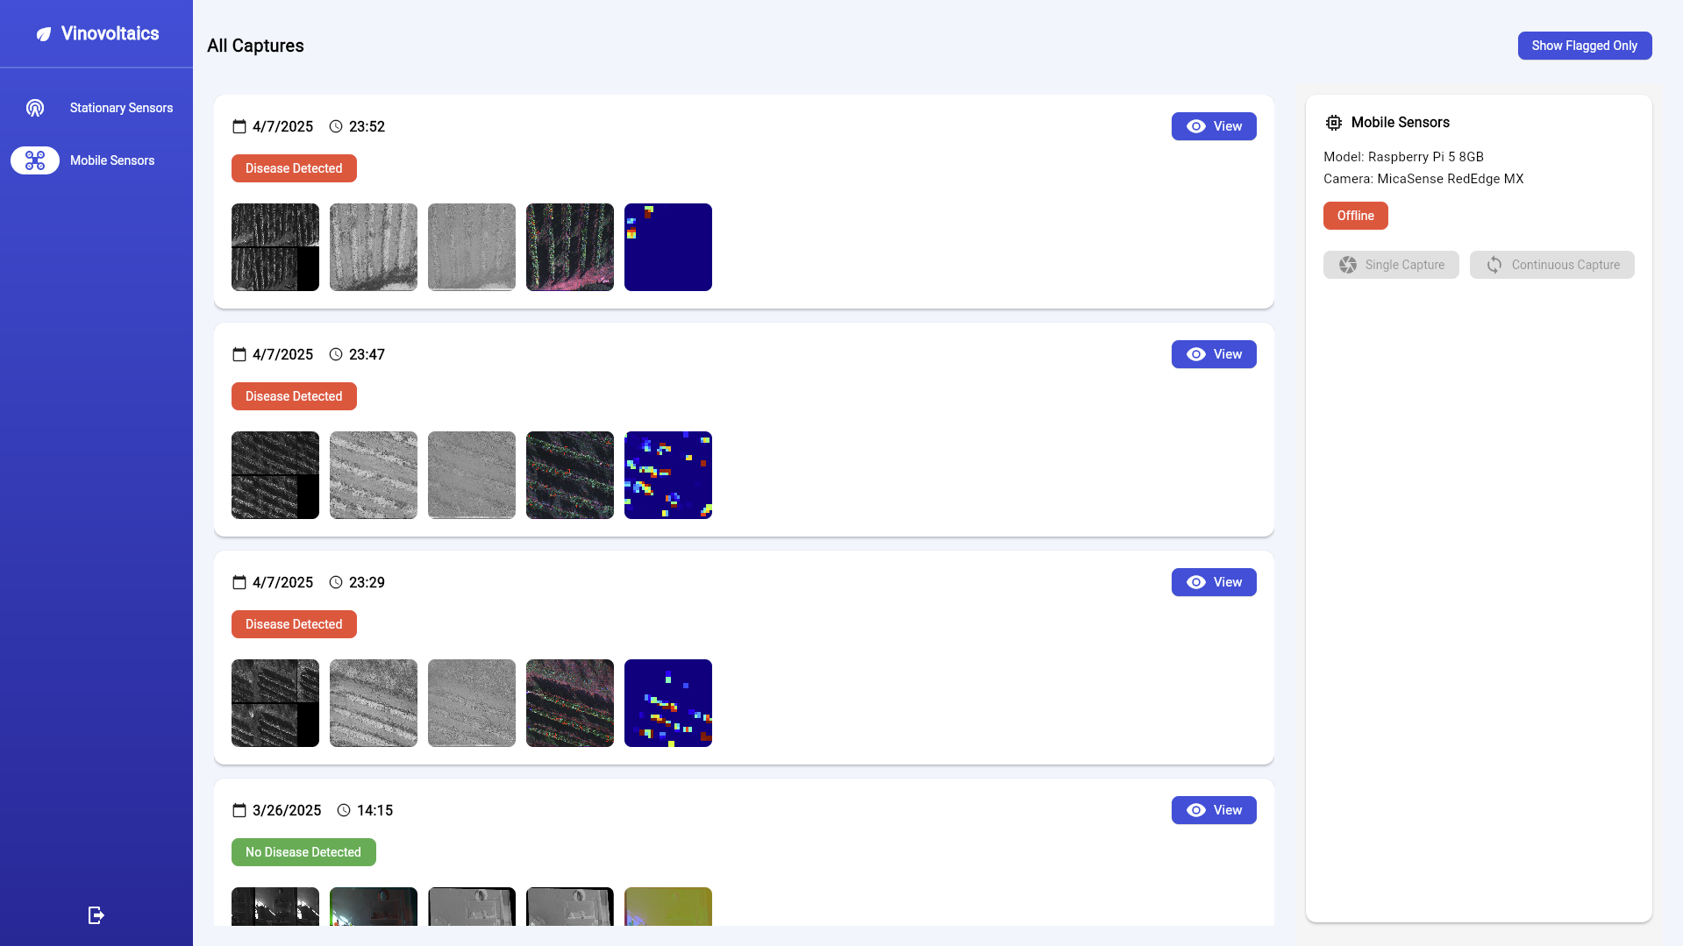

Once logged in, users land on the Home Dashboard. The Mobile Sensors view is especially tailored to interact with the disease detection pipeline. Captures are presented in a scrollable list of cards, each showing a timestamp, disease status indicator, image previews, and a button to view full details. Users can toggle between viewing all captures or only those flagged with disease detections.

Selecting a capture transitions to the Capture Detail View. This layout contains two synchronized panes: on the left, a pill-style tab bar allows the user to switch between raw images, NDVI, NDRE, and overlay views. On the right, the same overlay image is fused with a Grad-CAM heatmap using a real-time slider. Both panes support pan and zoom via Flutter’s InteractiveViewer for detailed inspection.

On the right most side, a hardware interaction panel is shown. This Pi Control Panel checks live device status by pinging the edge endpoint (/ping) and enables users to trigger new captures via single or continuous capture buttons. Device metadata such as Raspberry Pi version and camera model are also displayed. Each image is streamed from Firebase Storage, and all metadata is pulled from Firestore collections.

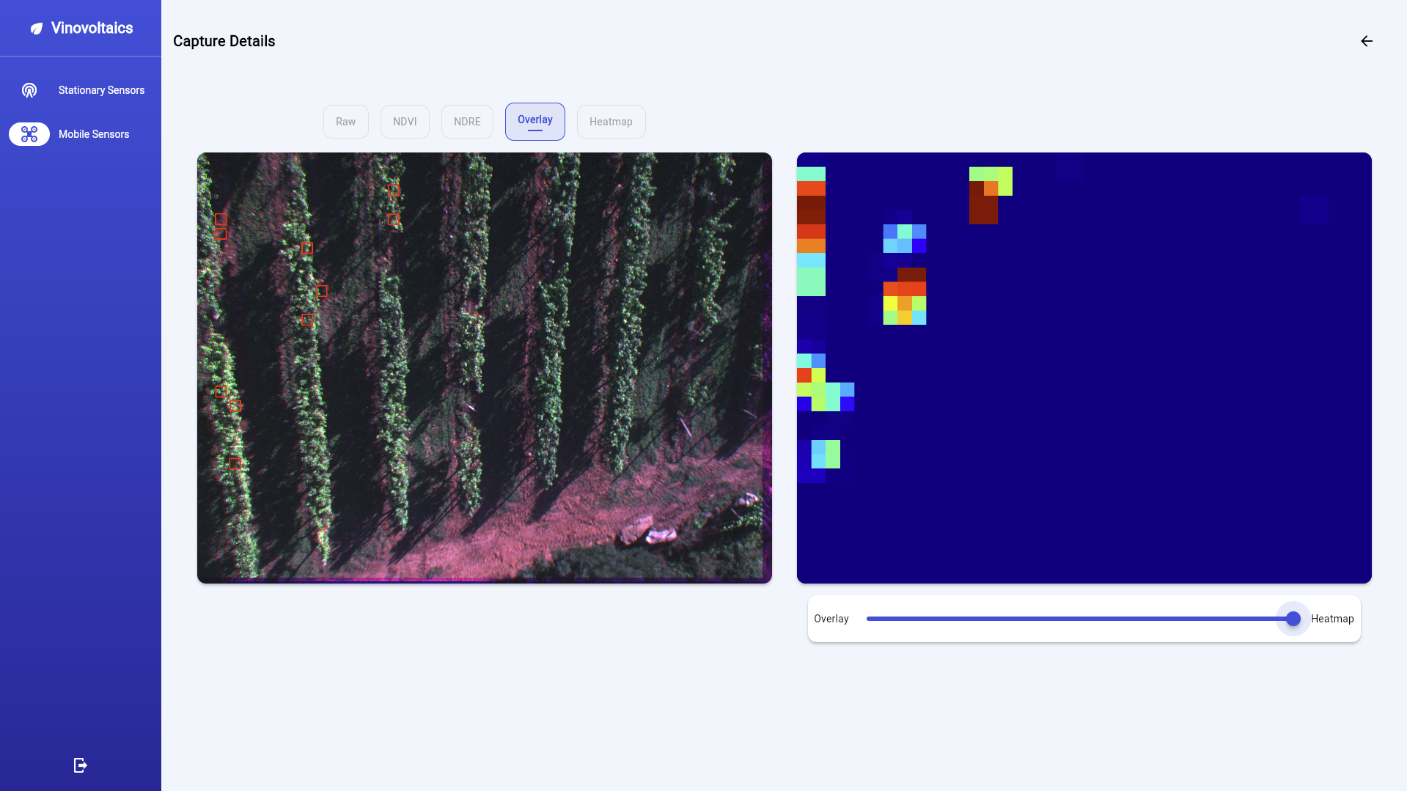

The repository can be found at: <https://github.com/Voltaics/agrivoltaics>

**Vibration system**

To facilitate field data collection using a camera mounted on a tractor, we designed a custom vibration isolation system. The objective of this system is to minimize the effect of tractor-induced vibrations on the camera, thereby enhancing the accuracy and quality of the collected visual data. The system is intended to be mounted on the front cover of the tractor.

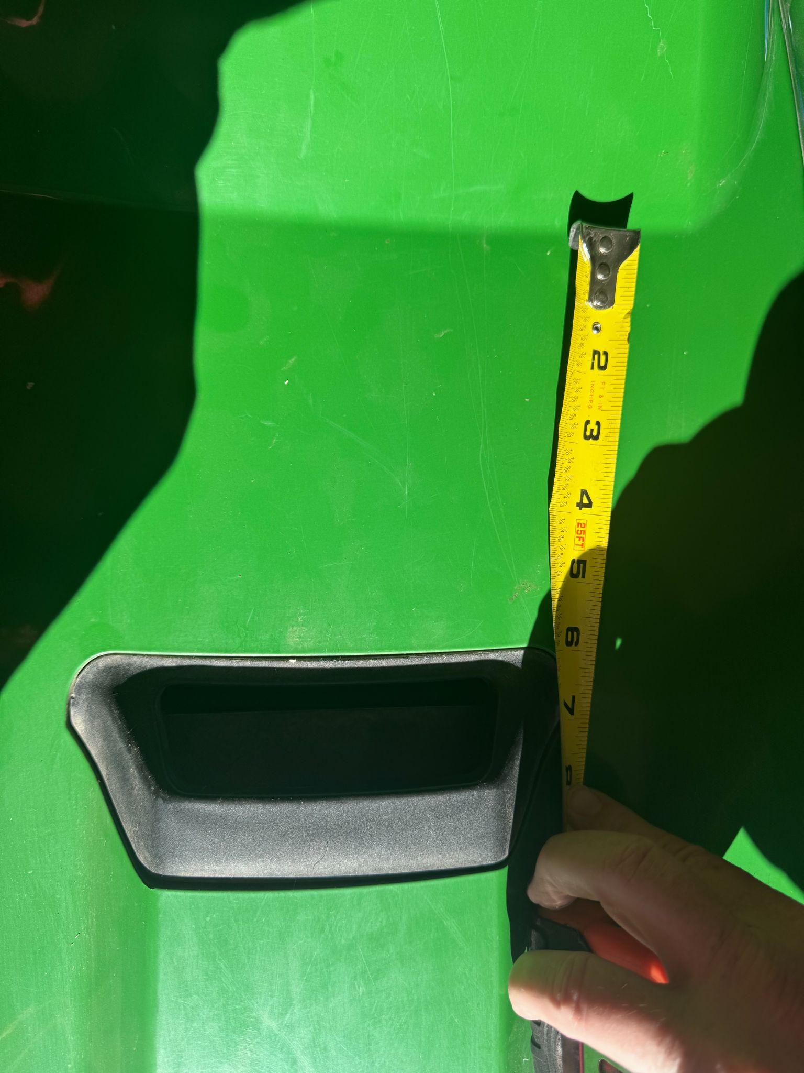

The vibration isolation system consists of a base plate equipped with a combination of shock mounts and spring-damper units. This configuration allows for effective attenuation of vibration frequencies typically encountered during tractor operation in the field.

### **Mechanical Configuration**

* The system includes **four shock mounts**, one at each corner of the base plate.
* A **spring-damper system** is installed in conjunction with each shock mount, forming a comprehensive vibration mitigation setup.
* The base plate is designed to connect directly to the tractor at these four corner points via the shock mounts.

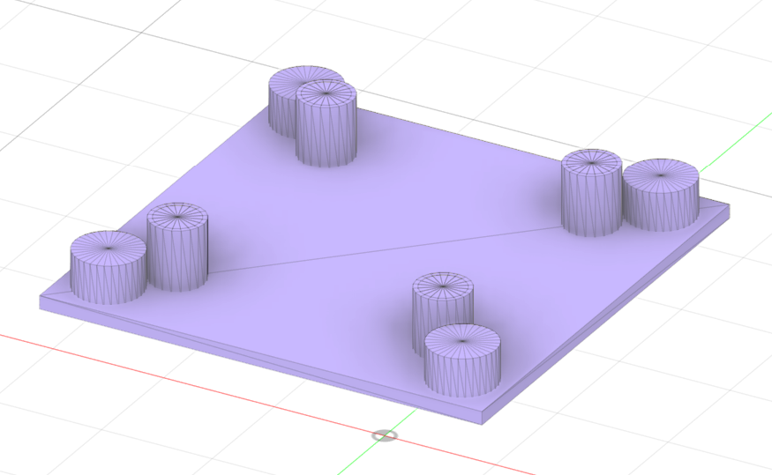

As shown in the picture, the outer corner represents the shock mount that connects the base plate with the tractor. And the inner spring damper system connects the base plate with the enclosure.

## **Prototype and/or Product Development and Testing [ABET 2, 3, 6]**

#### Manufacturing and Assembly

The prototype development process will involve integrating our various hardware components into a single, cohesive system. The Raspberry Pi 5 serves as the central processor, interfacing with the MicaSense RedEdge-MX multispectral camera to collect and preprocess images and video. These components are a part of the hardware assembly, mounted within a custom-designed enclosure featuring vibration dampening to ensure durability during drone flights. Compatibility with not only standard drones, but other farming equipment such as tractors has been prioritized to simplify and streamline deployment and field testing. The Raspberry Pi was selected as the processing unit for its affordability, computational efficiency, and ease of integration with other hardware components.

The drone platform is built using the Holybro X650 development kit, which offers an excellent balance of affordability and performance. One of the key advantages of the X650 is its payload capacity of up to 3kg, allowing it to easily carry the camera, Raspberry Pi 5, and power supplies without affecting flight stability. Its high cost-effectiveness makes it an affordable option for farmers, providing the necessary capabilities for precision agriculture at a lower price point. The Pixhawk 6X flight controller was chosen for its reliability and ability to support a wide range of payloads, making it ideal for precision agriculture and image collection tasks. Choose Mission Planner as the ground station, which is used for flight planning and monitoring, allowing for waypoint navigation, autonomous flight paths, and real-time telemetry, ensuring precise and repeatable missions.

#### Testing Objectives

The primary objective of the prototype testing phase is to demonstrate the prototype’s ability to perform accurate crop analysis. The system must adequately capture high resolution spectral data and identify and predict pests and diseases with an acceptable detection accuracy. The system's data transmission capabilities and user interface responsiveness will also be evaluated in order to ensure practical usability in field conditions and for farmers.

Testing will involve both controlled and real world scenarios. Controlled tests will verify hardware functionality and software integration, whereas field tests at a vineyard in Ohio will evaluate the system's performance in agricultural environments.

#### Test Plan

The testing process begins with bench tests to validate the functionality of individual components of the camera assembly and the Raspberry Pi. These tests will include making sure the camera can take pictures, upload them to the Pi, which can then move them up to the cloud. Then we will test the accuracy of our Ai model. For this we have sourced and curated a dataset that will be used to train and test the AI model in a controlled environment, assessing its detection accuracy and prediction capability. We decided to use 80 percent of our data to train, 20 percent to test accuracy of the model.

Drone tests will be held in the drone lab without anything attached to ensure the drones proper functioning and balance. Field testing will be our next step, with the drone mounted system capturing live data over a vineyard. The results will then be compared to ground-truth measurements. Metrics to gauge detection accuracy, prediction accuracy and processing time will be recorded to assess the prototype’s complete performance.

**Test Results**

Testing of the camera assembly went remarkably well, we were able to establish a robust pipeline from camera to Raspberry Pi to cloud relatively easily. Testing of the Ai model also went quite well, with a total combined accuracy of 83.2% which we considered successful. The testing data can be found below.

Vine Classifier:

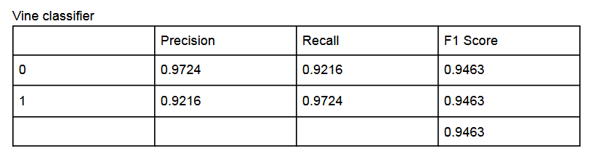

Disease Classifier:

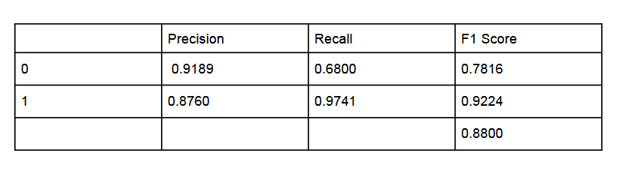

The drone testing is where we started to falter in our testing, the drone is having issues with take off, it lurches forward into a summersault repeatedly. We have hypotheses of what is causing this from a misbalance in the drones construction to software issues, but we have yet to find a solution. This conundrum halts our final phase of testing and seeing as we are running out of time in the semester, this will likely be left to a future group to solve and finish testing.

## **Social Impact [ABET 2, 4]**

The Hover Squad project has significant potential to drive global, economic, and environmental benefits, particularly for underserved communities in agriculture. The following outlines the societal implications of this work:

* Global/societal consideration of environmental factors. [ABET 2]

By reducing the need for blanket pesticide application, the proposed solution minimizes agricultural runoff, protecting vital waterways and ecosystems from chemical pollution. This innovation aligns with sustainable farming practices, contributing to a healthier environment.

The use of a multispectral camera to detect crop health issues early allows for targeted interventions, reducing chemical dependency and fostering eco-friendly agriculture.

* Reasonable cost and maintainability considerations. [ABET 4]

Traditional agricultural drones are prohibitively expensive for small-scale and subsistence farmers. The Hover Squad aims to bridge this gap by offering an affordable, replicable solution. The open-source nature of the project ensures that anyone can access the design and adapt it to their needs, promoting equity in agricultural technology.

The project also addresses accessibility by documenting the design process and providing clear guidelines for replication, which empowers farmers in resource-limited regions.

* Health and safety issues. [ABET 2]

By decreasing the overuse of pesticides, the project contributes to better public health outcomes, as farmers and surrounding communities are exposed to fewer harmful chemicals.

The autonomous drone operation reduces the need for human labor in potentially hazardous environments, such as fields heavily treated with chemicals.

* Equity and accessibility concerns. [ABET 4]

The project's modular and adaptable design takes into account varying agricultural practices across different cultures and regions. For example, the equipment is scalable for use in vineyards, rice paddies, or small crop fields.

Collaboration with local stakeholders ensures the technology is sensitive to cultural and regional nuances, enhancing its adoption and effectiveness.

**Future Work and Subsequent Development [ABET 7]**

1. **Project Limitations**

**Regulatory Compliance:** Future iterations should focus on overcoming regulatory challenges for autonomous drones, particularly in the U.S., where stringent FAA regulations apply. A potential solution is developing a localized compliance framework or exploring partnerships with regulatory bodies to facilitate wider deployment.

**Testing and Validation:** Additional field testing across diverse agricultural settings (e.g., tropical, arid, and temperate regions) is essential to validate the system’s robustness and adaptability.

1. **Additional Features**

**Expanded Data Capabilities:** Integrating additional sensors (e.g., LiDAR or thermal imaging) could enhance the system's ability to detect water stress, soil health, and canopy coverage.

**Obstacle Avoidance:** Adding the sensors needed for obstacle avoidance would allow the drone to get closer to its targets and would increase drone safety.

**Edge Computing:** Future designs could incorporate advanced edge computing devices to enable real-time AI processing onboard, reducing reliance on cloud infrastructure and improving scalability in regions with limited internet access.

1. **Project plan versus project completion: what did you aim for and what did you hit?**

A functional prototype was completed and computerized testing with publicly available datasets was performed. However live testing was not achieved yet due to issues with the prototype drone. We hope to fix any remaining issues with the prototype and document controls for a future team to be able to conduct testing more thoroughly. Due to a lack of AI training data from ground level we could not determine accuracy of the AI model from ground testing.

## **Summary and Conclusions [ABET 3]**

The project as a whole was a success with an asterisk next to it. We did create a camera assembly that is able to use Multispectral images and Ai to predict and point out pest and disease outbreaks that can be mounted to both a tractor and drone. The cost of the total camera assembly is about $3200 which is cheaper than other alternatives and also features a trainable Ai that can be adapted to any given region given enough data. We struggled to get our drone up in the air reliably which didn’t allow us to test things to the level that we would have desired on the vineyard which is a definite shortcoming of the project and shows that the ease of integration of this drone kit may be harder than we desired for farmers abroad. Another shortcoming is finding the data to create these datasets. People are very possessive of their data and usually don’t give it up for free which could greatly impact the usability of this technology in the future without more public data.

Overall the prototype created by this project does set out to do what we aimed for but with some bumps along the way. Our camera assembly would undoubtedly be of use to farmers given the right set of conditions are in play, such as availability of data for target pests and internet connection. We remain hopeful that if the drone could be figured out more easily we would have an even more useful and versatile system. Seeing as there are solutions to the problems listed, we are calling this a successful project that takes steps in the right direction to finding a better solution.

## **Team Design Reflection and Debriefing [ABET 5]**

1. List the most powerful learning moments or experiences you encountered. Why do you feel they were profound and how do you think they might shape your future approaches to problems?

The most powerful learning moments through the design process were attempting to acquire a drone platform, and our first test flights. Due to all the struggles we went through with drone acquisition we would definitely make sure to do extra research whenever dealing with products that may have difficulties shipping, and consulting experts on the subject earlier. We would also consult a subject matter expert when attempting to configure a device that we aren’t familiar with in the future to prevent any sort of damage during testing.

1. What have you learned about supporting and encouraging the members of your team? How might these lessons shape your future approaches to engineering problem solving and building teams? [ABET 5]

We have learned that it may be helpful to preemptively support other team members before they explicitly ask for help. Sometimes we can get stuck on a matter and reach out after multiple failed attempts instead of immediately. It can also feel embarrassing for some to ask for help. On that note we also learned to not be so embarrassed when asking for help, especially on a subject that is new to us.

1. What did you discover to be your team’s greatest strengths? What did you discover to be your team’s greatest weaknesses? What could you have done to ameliorate the weaknesses and further enhance the strengths?

We feel our team’s greatest strengths were work ethic, adaptability and perseverance. Our greatest weakness was communication. We could have scheduled more regular meetings for everyone to report their progress and discuss their solutions to ameliorate our weakness. To further enhance our strengths we feel it would have been helpful to specifically communicate our struggles more often, such as difficulty finding a viable drone platform within budget.

1. All team members would have at this point engaged in multiple co-op experiences. Did you bring any lessons from practical co-op work into this project? Did you bring any lessons from this project into ongoing co-op or other real-world work? If so, what were those lessons and how did they provide you with skills and aptitudes you might not otherwise have possessed?

We feel the largest help from co-op and real world work was the experience with project scheduling and delegation of tasks. We were able to delegate out tasks efficiently and to the proper team members easily.

1. What advice would you give to future students to help them do well in senior team design? Note: this is advice about how to do well in the class and get the most from it as opposed to advice on how to achieve the engineering product outcomes similar to yours.

I would advise students to commit to a project that they have a high interest in and to make sure to try to keep on schedule as much as possible. Our biggest issues all came from unforeseen issues that extended our testing date until the end of the semester.

## **References [ABET 7]**

[1] H. Slimani, J. El Mhamdi, and A. Jilbab, "Assessing the advancement of artificial intelligence and drones’ integration in agriculture through a bibliometric study," International Journal of Electrical and Computer Engineering, vol. 14, no. 1, pp. 878–890, Feb. 2024. DOI: 10.11591/ijece.v14i1.pp878-890​

[2] H. Wang, T. Li, E. Nishida, Y. Kato, Y. Fukano, and W. Guo, "Drone-based harvest data prediction can reduce on-farm food loss and improve farmer income," Plant Phenomics, vol. 5, Article 0086, Sept. 2023. DOI: 10.34133/plantphenomics.0086​

​

[3] A. Rejeb, A. Abdollahi, K. Rejeb, and H. Treiblmaier, "Drones in agriculture: A review and bibliometric analysis," Computers and Electronics in Agriculture, vol. 198, Article 107017, May 2022. DOI: 10.1016/j.compag.2022.107017​

[4] AI drones successfully monitor crops to report the ideal time to harvest," Plant Phenomics, Oct. 4, 2023. DOI: [10.34133/plantphenomics.0086](https://doi.org/10.34133/plantphenomics.0086)​

[5] J. Feng et al., “Autonomous Detection of Spodoptera frugiperda by Feeding Symptoms Directly from UAV RGB Imagery,” Applied Sciences, vol. 12, no. 5, p. 2592, Mar. 2022, doi: <https://doi.org/10.3390/app12052592>.

[6] R. Zhao et al., “Goji Disease and Pest Monitoring Model Based on Unmanned Aerial Vehicle Hyperspectral Images,” Sensors, vol. 24, no. 20, pp. 6739–6739, Oct. 2024, doi: <https://doi.org/10.3390/s24206739>.

[7] F. Vanegas, D. Bratanov, K. Powell, J. Weiss, and F. Gonzalez, “A Novel Methodology for Improving Plant Pest Surveillance in Vineyards and Crops Using UAV-Based Hyperspectral and Spatial Data,” Sensors, vol. 18, no. 1, p. 260, Jan. 2018, doi: https://doi.org/10.3390/s18010260.

[8] L. Li, H. Zhao, and N. Liu, “MCD-Yolov5: Accurate, Real-Time Crop Disease and Pest Identification Approach Using UAVs,” Electronics, vol. 12, no. 20, p. 4365, Jan. 2023, doi: <https://doi.org/10.3390/electronics12204365>.

[9] Y. Wang, C. Wei, H. Sun, and A. Qu, “Design of Intelligent Detection Platform for Wine Grape Pests and Diseases in Ningxia,” Plants, vol. 12, no. 1, p. 106, Jan. 2023, doi: https://doi.org/10.3390/plants12010106.

Pimentel, M. F., & Medeiros, A. C. D. (2022). UAV images of vineyards and detection of Botrytis cinerea in red grapes. Zenodo. https://doi.org/10.5281/zenodo.7383601

Dinis, J. et al. (2024). Grape Disease Multispectral UAV Dataset. Zenodo. https://doi.org/10.5281/zenodo.10362568